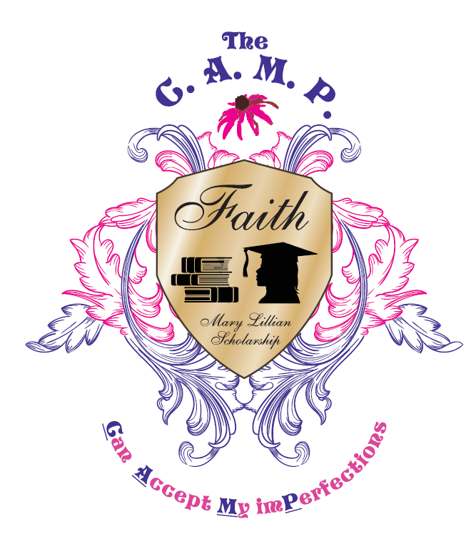
Mary Lillian Scholarship
Academic Book Scholarship Application

The C.A.M.P., Can Accept My imPerfections will provide competitive scholarships. Scholarship are designated for minority female students, which will be paid directly to the institution. Applicants will be judged on the criteria’s and Personal Goal Statement.
Applicant Academic Scholarship Criteria
Minority female Reside in Seminole County, FL
Minimum GPA of 3.0 Letter of college acceptance
Demonstrate community service and involvement
Criteria for Selection
To avoid disqualification, please comply with all requirements for the award. A complete application packet contains the following:
- Complete application form including a typed Personal Goal Statement
- Two (2) letters of recommendation that include contact information
- Official unopened transcript from all high schools that you have attended with a cumulative GPA listed
- Attendance at yearly event is required to be awarded the scholarship.
How To Apply
Submit application on the official Scholarship Application Form (attached)
Application must be signed by a parent/guardian
Send the completed application packet to:
The C.A.M.P.
PO Box 470352
Lake Monroe, FL 32747
Personal information
First Name ________________________ Last Name_____________________________
Home address ____________________City and State______________ Zipcode_______
Home number______________ Cell number________________
High School Attending _____________________________________
High School Address _______________________________________
Signature of Guidance Counselor_____________________________
College hoping to attend ___________________________________
Note: Application due date will be placed on The C.A.M.P.’s social media and website updates or contact us for specific date details.

